Exercise 1: Control Structures

Scenario 1:

CREATE TABLE Customers (
CustomerID NUMBER PRIMARY KEY,
Name VARCHAR2(100),
Age NUMBER
);
CREATE TABLE Loans (
LoanID NUMBER PRIMARY KEY,
CustomerID NUMBER,
InterestRate NUMBER,
FOREIGN KEY (CustomerID) REFERENCES Customers(CustomerID)
);
INSERT INTO Customers VALUES (1, 'Ali', 62);
INSERT INTO Customers VALUES (2, 'Ajay', 45);
INSERT INTO Customers VALUES (3, 'Raju', 70);

INSERT INTO Loans VALUES (111, 1, 8.5);
INSERT INTO Loans VALUES (112, 2, 9.0);
INSERT INTO Loans VALUES (113, 3, 5.5);
COMMIT;

BEGIN
FOR rec IN (
SELECT l.LoanID, l.InterestRate
FROM LOANS l
JOIN Customers c ON l.CustomerID = c.CustomerID
WHERE c.Age > 60
) LOOP
UPDATE LOANS
SET InterestRate = rec.InterestRate - 1
WHERE LoanID = rec.LoanID;
END LOOP;

COMMIT;
END;
/

SELECT * FROM Loans;

OUTPUT:

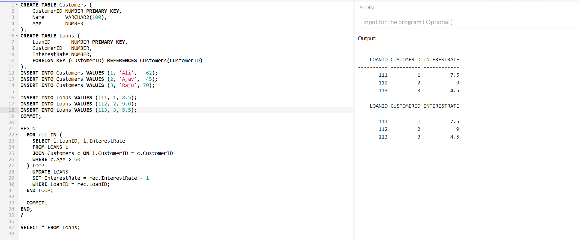

========================================================================

Scenario 2:

CREATE TABLE Customers (
CustomerID NUMBER PRIMARY KEY,
Name VARCHAR(100),
Age NUMBER,
Balance NUMBER,
is_vip VARCHAR(5) default 'FALSE'
);
INSERT INTO Customers (CustomerID, Name, Age, Balance) VALUES (1, 'Ajay', 45, 20000);
INSERT INTO Customers (CustomerID, Name, Age, Balance) VALUES (2, 'Varun', 57, 10000);
INSERT INTO Customers (CustomerID, Name, Age, Balance) VALUES (3, 'Ananya', 60, 9000);
COMMIT;
BEGIN
FOR cust_rec IN (
SELECT CustomerID, Name, Balance
FROM Customers
WHERE Balance > 10000
) LOOP
UPDATE Customers
SET is_vip = 'TRUE'
WHERE CustomerID = cust_rec.CustomerID;
DBMS_OUTPUT.PUT_LINE(cust_rec.Name || ' is now a VIP customer!');

END LOOP;

COMMIT;
END;
/
SELECT * FROM CUSTOMERS;

OUTPUT:

CustomerID | Name | Age | Balance | is_vip
1 | Ajay | 45 | 20000 | FALSE
2 | Varun | 57 | 10000 | FALSE
3 | Ananya | 60 | 9000 | FALSE

Ajay is now a VIP customer!

CustomerID | Name | Age | Balance | is_vip
1 | Ajay | 45 | 20000 | TRUE
2 | Varun | 57 | 10000 | FALSE
3 | Ananya | 60 | 9000 | FALSE

========================================================================

Scenario 3:

CREATE TABLE Customers (
CustomerID NUMBER PRIMARY KEY,
Name VARCHAR2(100)
);

CREATE TABLE Loans (
LoanID NUMBER PRIMARY KEY,
CustomerID NUMBER,
DueDate DATE,
LoanAmount NUMBER,
FOREIGN KEY (CustomerID) REFERENCES Customers(CustomerID)
);
INSERT INTO Customers VALUES (1, 'Ajay');
INSERT INTO Customers VALUES (2, 'Arun');
INSERT INTO Customers VALUES (3, 'Navya');

INSERT INTO Loans VALUES (10, 1, SYSDATE + 15, 50000);
INSERT INTO Loans VALUES (11, 2, SYSDATE + 30, 8000);
INSERT INTO Loans VALUES (12, 3, SYSDATE + 20, 10000);
COMMIT;

DECLARE
v_due_date DATE := SYSDATE + 30;
BEGIN
FOR loan_rec IN (SELECT LoanID, CustomerID, DueDate
FROM Loans
WHERE DueDate <= v_due_date AND DueDate >= SYSDATE
) LOOP
DBMS_OUTPUT.PUT_LINE('Reminder: Loan ID ' || loan_rec.LoanID ||
' for Customer ID ' || loan_rec.CustomerID ||
' is due on ' || TO_CHAR(loan_rec.DueDate, 'DD-MON-YYYY'));
END LOOP;
END;
/
SELECT * FROM Loans

OUTPUT:

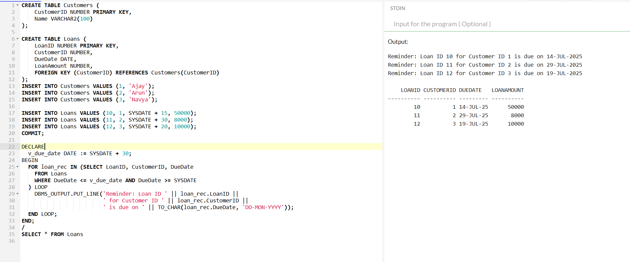

==================================================

Exercise 3: Stored Procedures

Scenario 1:

CREATE TABLE Accounts (
AccountID NUMBER PRIMARY KEY,
CustomerName VARCHAR(50),
AccountType VARCHAR2(20),
Balance NUMBER
);
INSERT INTO Accounts VALUES (1, 'Alice', 'Savings', 10000);
INSERT INTO Accounts VALUES (2, 'Bob', 'Checking', 5000);
INSERT INTO Accounts VALUES (3, 'Charlie', 'Savings', 20000);
COMMIT;
CREATE OR REPLACE PROCEDURE ProcessMonthlyInterest IS
BEGIN
FOR acc_rec IN (
SELECT AccountID, Balance
FROM Accounts
WHERE AccountType = 'SAVINGS'
) LOOP
UPDATE Accounts
SET Balance = Balance + (Balance * 0.01)
WHERE AccountID = acc_rec.AccountID;
END LOOP;

COMMIT;
END;
/
SELECT * FROM Accounts

OUTPUT:

AccountID | CustomerName | AccountType | Balance
1 | Alice | Savings | 10000
2 | Bob | Checking | 5000
3 | Charlie | Savings | 20000

AccountID | CustomerName | AccountType | Balance
1 | Alice | Savings | 10100
2 | Bob | Checking | 5000
3 | Charlie | Savings | 20200

======================================================================

Scenario 2:

CREATE TABLE Employees (
EmployeeID NUMBER PRIMARY KEY,
Name VARCHAR2(100),
Department VARCHAR2(50),
Salary NUMBER
);
INSERT INTO Employees VALUES (1, 'Anand', 'HR', 50000);
INSERT INTO Employees VALUES (2, 'John', 'IT', 60000);
INSERT INTO Employees VALUES (3, 'Neha', 'IT', 70000);
INSERT INTO Employees VALUES (4, 'Shraddha', 'Finance', 55000);

COMMIT;

CREATE OR REPLACE PROCEDURE UpdateEmployeeBonus(
p_department IN VARCHAR2,
p_bonus_pct IN NUMBER
) AS
BEGIN
UPDATE Employees
SET Salary = Salary + (Salary * p_bonus_pct / 100)
WHERE Department = p_department;
DBMS_OUTPUT.PUT_LINE('Bonus of ' || p_bonus_pct || '% applied to department: ' || p_department);

COMMIT;
END;
/
BEGIN
UpdateEmployeeBonus('IT',10);
END;
/
SELECT * FROM Employees;

OUTPUT:

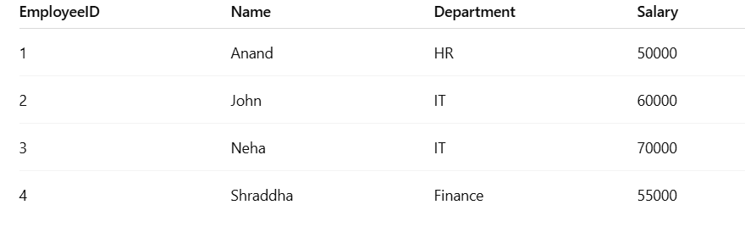

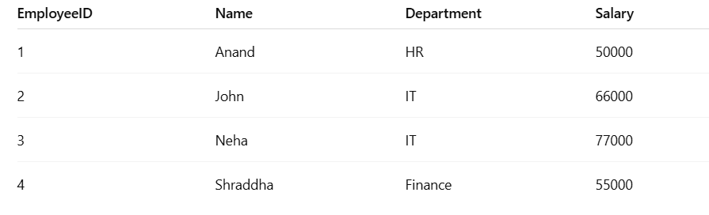

======================================================================

Scenario 3:

CREATE TABLE Accounts (
AccountID NUMBER PRIMARY KEY,
CustomerName VARCHAR(50),
Balance NUMBER
);
INSERT INTO Accounts VALUES (1, 'Adam', 10000);
INSERT INTO Accounts VALUES (2, 'jack', 5000);

COMMIT;
CREATE OR REPLACE PROCEDURE TransferFunds(
p_from_account IN NUMBER,
p_to_account IN NUMBER,
p_amount IN NUMBER
) IS
v_balance NUMBER;
BEGIN
SELECT Balance INTO v_balance
FROM Accounts
WHERE AccountID = p_from_account;

IF v_balance < p_amount THEN
DBMS_OUTPUT.PUT_LINE('Transfer failed: Insufficient balance.');
RETURN;
END IF;
UPDATE Accounts
SET Balance = Balance - p_amount
WHERE AccountID = p_from_account;
UPDATE Accounts
SET Balance = Balance + p_amount
WHERE AccountID = p_to_account;

COMMIT;
DBMS_OUTPUT.PUT_LINE('Transfer of ' || p_amount ||
' from account ' || p_from_account ||
' to account ' || p_to_account || ' completed.');
EXCEPTION
WHEN NO_DATA_FOUND THEN
DBMS_OUTPUT.PUT_LINE('Transfer failed: One or both accounts do not exist.');
WHEN OTHERS THEN
DBMS_OUTPUT.PUT_LINE('Unexpected error: ');
ROLLBACK;
END;
/
BEGIN
TransferFunds(1, 2, 3000);
END;
/
SELECT * FROM ACCOUNTS;

OUTPUT:

AccountID | CustomerName | Balance
1 | Adam | 10000
2 | Jack | 5000

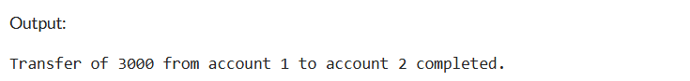

AccountID | CustomerName | Balance
1 | Adam | 7000
2 | Jack | 8000

=====================================================================

